LOAN ELIGIBILITY PREDICTION

## **ABSTRACT**

In the modern financial landscape, accurately determining loan eligibility is a crucial function for banks and financial institutions to minimize risk and ensure responsible lending. This project, titled *“Loan Eligibility Prediction Using Machine Learning,”* aims to automate and enhance the traditional loan approval process through data-driven analysis and predictive modelling. The objective of the project is to build a machine learning model that can predict whether a loan applicant is eligible for a loan based on key parameters such as income, credit history, employment status, loan amount, education, marital status, and other demographic and financial details. The model helps reduce manual intervention, avoid bias, and accelerate decision-making by financial analysts and loan officers.

The project workflow begins with data collection, followed by data cleaning, preprocessing, and exploratory data analysis (EDA) to understand patterns and relationships within the dataset. Feature engineering techniques are applied to improve model performance. Multiple algorithms such as Logistic Regression, Decision Trees, and Support Vector Machines are evaluated, and the best-performing model is selected based on accuracy, precision, recall, and F1 score.

By integrating domain knowledge from finance and applying technical skills in Python and machine learning, this project provides an intelligent solution that aligns with the evolving demands of digital finance. The results demonstrate how predictive analytics can be a powerful tool in the financial sector, especially for assessing creditworthiness and improving operational efficiency. This solution is scalable and can be adapted for various financial products beyond loans, such as credit cards and mortgages.

This project not only bridges the gap between financial theory and data science but also demonstrates the impact of data-driven decision-making in real-world applications.

# **I - INTRODUCTI****ON**

The Loan Eligibility Prediction project is a data science initiative that aims to automate and streamline the loan approval process using machine learning models. In traditional banking environments, determining whether a customer is eligible for a loan is a time-consuming process that involves manual verification of numerous financial parameters, such as income, credit history, employment status, and more. This manual approach is not only inefficient but also prone to human bias and inconsistencies. The goal of this project is to develop a predictive model that accurately determines the eligibility of applicants for loans based on their personal and financial data, using supervised learning techniques.

As digital banking and fintech solutions gain popularity, financial institutions increasingly rely on data-driven insights for decision-making. The Loan Eligibility Prediction system is designed to address this demand by offering a reliable, scalable, and automated solution to assess loan applications. The project involves collecting a real-world dataset containing historical loan application data, preprocessing it to ensure consistency, handling missing values, encoding categorical variables, and then training classification models to learn patterns that distinguish approved from rejected applications.

The project explores the performance of different machine learning algorithms such as Logistic Regression and Decision Tree Classifier to evaluate which model yields the best results in terms of accuracy, precision, and recall. The models are trained on features such as applicant income, loan amount, loan term, credit history, dependents, and property area, among others. By training these models on labeled data, the system can predict whether a new applicant is likely to be approved or not. In addition to raw prediction, the system provides explanations using basic feature importance metrics, offering transparency in the decision-making process.

To enhance accessibility, a lightweight user interface can be deployed, where banking staff or applicants themselves can input details and receive real-time eligibility decisions. This predictive model not only improves efficiency but also helps financial institutions reduce default rates by approving loans to applicants with a high likelihood of repayment. With a strong emphasis on fairness and data quality, this project stands as a practical demonstration of how machine learning can support responsible and inclusive lending practices in the modern financial ecosystem.

# **II - LITERATURE SURVEY**

1.**Title:** Loan Prediction Using Machine Learning  
**Author(s):** Sharma & Gupta (2019)  
**Algorithm(s):** Decision Tree  
**Dataset:** UCI Loan Dataset  
**Accuracy:** 85.2%  
The authors applied Decision Tree algorithms to predict loan eligibility and found it effective in identifying eligible applicants based on structured financial data.

2.**Title:** Predictive Modelling for Loan Approval Using ML  
**Author(s):** Patel et al. (2020)  
**Algorithm(s):** Logistic Regression, Random Forest  
**Dataset:** Kaggle Loan Data  
**Accuracy:** 87.5%  
This study compared basic and ensemble algorithms and concluded that Random Forest models provided better predictive performance than Logistic Regression.

3. **Title:** Comparative Study of ML Algorithms for Loan Approval  
**Author(s):** Aggarwal & Goel (2021)  
**Algorithm(s):** Random Forest, SVM, KNN  
**Dataset:** Public Sector Bank Data  
**Accuracy:** 90.1%  
The research evaluated multiple algorithms and highlighted Random Forest as the most accurate model for classifying loan applications.

4.**Title:** A Machine Learning Approach for Predicting Loan Default  
**Author(s):** Khan & Rehman (2018)  
**Algorithm(s):** Logistic Regression  
**Dataset:** Private Bank Loan Records  
**Accuracy:** 84.6%  
This paper emphasized the importance of credit history and income level in predicting loan defaults using logistic models.

5. **Title:** AI to Predict Loan Eligibility  
**Author(s):** IBM Watson Blog (2020)  
**Algorithm(s):** Gradient Boosting  
**Dataset:** In-house Banking Data  
**Accuracy:** 91.3%  
IBM implemented AI-driven models that delivered real-time loan eligibility decisions and improved processing time.

6. **Title:** Loan Approval Prediction Using XG Boost  
**Author(s):** Saini et al. (2021)  
**Algorithm(s):** XG Boost  
**Dataset:** Kaggle Dataset  
**Accuracy:** 93.0%  
XG Boost was identified as the top-performing algorithm for handling structured loan application data with high dimensionality.

7. **Title:** Role of Feature Selection in Loan Prediction  
**Author(s):** Kaur & Singh (2020)  
**Algorithm(s):** Random Forest with Feature Selection  
**Dataset:** Indian Loan Records  
**Accuracy:** 88.9%  
The study highlighted that selecting key features like credit history, income, and loan amount improved model efficiency.

8. **Title:** Use of Machine Learning in Risk Assessment  
**Author(s):** Thomas et al. (2019)  
**Algorithm(s):** Naive Bayes, Logistic Regression  
**Dataset:** Custom Bank Dataset  
**Accuracy:** 82.4%  
This research focused on automating risk assessment and reducing manual errors using ML classification techniques.

9. **Title:** Real-Time Loan Approval System Using Machine Learning  
**Author(s):** Bhatia et al. (2022)  
**Algorithm(s):** Random Forest  
**Dataset:** API-integrated Dataset  
**Accuracy:** 89.7%  
The paper introduced a real-time model that utilized integrated APIs and Random Forest for immediate approval decisions.

10. **Title:** A Deep Learning Approach to Loan Default Prediction  
**Author(s):** Varma et al. (2022)  
**Algorithm(s):** Deep Neural Network  
**Dataset:** Synthetic Loan Dataset  
**Accuracy:** 94.2%  
Deep learning was shown to outperform traditional models when sufficient and clean data was available.

11. **Title:** Predictive Analytics in Credit Risk Management  
**Author(s):** Gupta & Rani (2019)  
**Algorithm(s):** Logistic Regression, Decision Tree  
**Dataset:** Loan Default History  
**Accuracy:** 85.6%  
The study focused on managing credit risk using historical data and basic classification techniques.

12. **Title:** A Study on Credit Scoring Models Using ML  
**Author(s):** Jain et al. (2020)  
**Algorithm(s):** SVM, Logistic Regression  
**Dataset:** Credit Score Data  
**Accuracy:** 86.1%  
SVM was found effective but sensitive to noisy and unscaled data in credit scoring models.

13. **Title:** ML Techniques for Credit Risk Evaluation  
**Author(s):** Zhang et al. (2019)  
**Algorithm(s):** SVM, Random Forest  
**Dataset:** Financial Dataset  
**Accuracy:** 89.4%  
This comparative study supported supervised models for accurate credit classification.

14. **Title:** Financial Inclusion Through ML-Based Loan Screening  
**Author(s):** Reddy & Srinivas (2021)  
**Algorithm(s):** Logistic Regression  
**Dataset:** Rural Bank Loan Records  
**Accuracy:** 83.2%  
This research showed how ML helped rural banks in automating loan approvals for small-ticket loans.

15. **Title:** Credit Scoring Models Using Ensemble Learning  
**Author(s):** Kumar & Sharma (2023)  
**Algorithm(s):** Bagging, Boosting  
**Dataset:** Kaggle Loan Prediction Data  
**Accuracy:** 92.5%  
Ensemble models were highly effective in boosting prediction accuracy and model stability.

16. **Title:** ML-Based Risk Analytics in Banking  
**Author(s):** Mehta et al. (2018)  
**Algorithm(s):** Random Forest, Decision Tree  
**Dataset:** Public Bank Datasets  
**Accuracy:** 88.1%  
The authors concluded that ML-based analytics can significantly improve risk profiling in banks.

17. **Title:** Credit Approval Prediction Using Neural Networks  
**Author(s):** Roy et al. (2021)  
**Algorithm(s):** Artificial Neural Network  
**Dataset:** Private Sector Credit Dataset  
**Accuracy:** 91.0%  
Neural networks were found to be powerful tools in understanding nonlinear relationships in loan data.

18. **Title:** Ensemble Learning for Loan Approval  
**Author(s):** Thomas & Rao (2022)  
**Algorithm(s):** Voting Classifier  
**Dataset:** Merged Financial Records  
**Accuracy:** 90.6%  
This paper used a voting ensemble of multiple classifiers to improve loan approval outcomes.

19. **Title:** Loan Default Detection with Machine Learning  
**Author(s):** Das & Bhowmik (2020)  
**Algorithm(s):** Decision Tree, KNN  
**Dataset:** Regional Bank Data  
**Accuracy:** 85.9%  
The study used traditional classifiers to detect risk-prone loan applicants.

20. **Title:** Predicting Loan Eligibility Using ML Algorithms  
**Author(s):** Nair & Joseph (2021)  
**Algorithm(s):** Logistic Regression, SVM  
**Dataset:** Kaggle Loan Dataset  
**Accuracy:** 86.7%  
The researchers concluded that Logistic Regression remains an interpretable and dependable choice for loan prediction.

**III - OVERVIEW**

In the current age of digital transformation, the financial services industry is rapidly evolving through the adoption of advanced technologies such as Artificial Intelligence (AI) and Machine Learning (ML). One of the key challenges faced by banks and financial institutions is the accurate and efficient evaluation of loan applications. Traditionally, loan processing involved time-consuming manual assessments based on fixed criteria and subjective judgments. However, with the growing number of applicants and increasing complexity of financial data, the need for a reliable, automated system has become more critical than ever.

This project titled **“Loan Eligibility Prediction Using Machine Learning”** aims to develop a predictive model that can assess whether an applicant is eligible for a loan based on a variety of personal, financial, and employment-related attributes. The model leverages historical loan application data and applies machine learning algorithms to identify patterns and correlations that help predict loan eligibility. By automating this process, the model not only accelerates decision-making but also reduces human bias, enhances accuracy, and supports risk mitigation strategies for lending institutions.

Loan eligibility prediction is particularly significant in the financial sector, as it directly impacts loan approval rates, customer satisfaction, and most importantly, the institution’s exposure to credit risk. Implementing a data-driven solution helps lenders make more informed and objective decisions, especially in environments where speed and precision are essential. In addition, the integration of such predictive models aligns with current industry trends toward digital banking and smart financial systems.

As an MBA student specializing in Business Analysis and Finance, this project provides an excellent opportunity to blend theoretical financial knowledge with practical data science applications. It serves as a real-world example of how business decisions can be optimized using analytics and technology.

**3.1 Problem Statement**

Loan disbursement decisions are critical for the success of financial institutions. Incorrect approvals can lead to high default rates, while unnecessary rejections may drive away potential customers. Manual processing of loan applications is not scalable in today’s fast-paced financial environment. Furthermore, inconsistencies in human judgment can negatively impact both the institution and the applicant.

This project addresses the following key problems:

* How to automate the loan eligibility process using machine learning?
* How to improve prediction accuracy using financial and demographic data?
* How to interpret model results for business use?

By solving these issues, the project aims to support data-driven decision-making in loan processing and contribute to the digital transformation of financial services.

**3.2 Objective of the Project**

The main objectives of this project are:

* To analyse a dataset containing historical loan application data.
* To preprocess and clean the data for machine learning modelling.
* To build and evaluate multiple classification algorithms such as Logistic Regression, Decision Tree, and Random Forest.
* To identify the most important factors that influence loan eligibility.
* To develop a model that predicts whether a loan should be approved or not based on applicant information.
* To assist financial institutions in minimizing loan default risk through automated decision support.

**3.3 Scope of the Project**

This project is primarily focused on binary classification: predicting whether a loan should be **approved** or **rejected** based on the applicant’s attributes. The model is built using Python and essential machine learning libraries like pandas, scikit-learn, and matplotlib for data handling, modeling, and visualization. The scope includes:

* Handling categorical and numerical data.
* Evaluating models with accuracy, precision, recall, and F1-score.
* Visualizing the importance of features influencing eligibility.
* Developing a model that can be deployed in banking applications.

This project does not include aspects such as live deployment, integration with real-time banking systems, or the use of credit bureau APIs.

**3.4 Importance of the Study**

In the modern financial ecosystem, risk mitigation is a major priority. A well-built loan eligibility model helps banks:

* Save time by automating initial screening.
* Increase transparency in the decision-making process.
* Reduce the risk of loan default by approving only eligible candidates.
* Enhance customer experience through quicker decisions.

As an MBA student specializing in Business Analysis and Finance, this project allowed the integration of core business understanding with technical skills in data science, helping bridge the gap between theoretical finance concepts and practical AI applications.

**3.5 Methodology**

The project followed a standard data science workflow:

1. **Problem Understanding** – Define the business challenge.
2. **Data Collection** – Use open-source or synthetic datasets with relevant features.
3. **Data Preprocessing** – Handle missing values, encode categorical variables, and normalize data.
4. **Exploratory Data Analysis (EDA)** – Understand relationships between features.
5. **Model Building** – Train classification models such as Logistic Regression, Decision Tree, etc.
6. **Model Evaluation** – Use metrics like accuracy, confusion matrix, and ROC-AUC score.
7. **Result Interpretation** – Analyse which variables are key indicators.
8. **Conclusion and Future Scope** – Recommend improvements and next steps.

**IV - METHODOLOGY**

This chapter outlines the structured methodology used in the design and development of the Loan Eligibility Prediction System, detailing every stage from data collection to model deployment. The implementation follows a modular Data Science Life Cycle for reproducibility, agility, and integration readiness in financial systems such as banking dashboards or Power BI.

**4.1 Proposed Methodology Overview**

The core of the proposed system is a machine learning classification pipeline that predicts whether a loan application should be Approved or Rejected, based on applicant-provided information.

**Methodology Workflow**

The process involves the following key phases:

*Figure 4.1*

**Diagram**

*A schematic representation of the system flow is included in Figure 4.1 (to be inserted in the document.*

**4.2 Process Description**

Applicants fill out a digital loan application form. The form captures attributes such as income, employment, and credit history. These are mapped to a trained ML model to predict loan approval.

* Each record from the dataset is used to train ML classifiers.
* Upon form submission, the input is validated, transformed, and fed into the model.
* The model returns a binary decision and a probability score.

The following algorithms were implemented:

* Support Vector Machine (SVM)
* K-Nearest Neighbor (KNN)
* Decision Tree (DT)

The most accurate algorithm is selected as the final predictive model. The trained system runs autonomously and supports integration with Power BI dashboards and banking APIs.

**4.3 Machine Learning Approach**

**Learning Type**

* Supervised Learning was chosen due to the labeled dataset (Approved/Rejected).

**Algorithms Used**

|  |  |
| --- | --- |
| Algorithm | Description |
| Support Vector Machine | **Effective in high-dimensional spaces** |
| KNN | **Lazy learning, instance-based model** |
| Decision Tree | **Rule-based decisions, interpretable** |

**4.4 System Architecture**

The system is modular and easy to deploy in services like Flask, Power BI, or Gradio. Components include:

**1. Input Module**

* Accepts applicant data (e.g., Gender, Income, Credit History).
* Supports single or batch mode processing.

**2. Preprocessing Module**

* Missing Value Handling: Median for numeric, mode for categorical.
* Outlier Treatment: Log scaling of income variables.
* Encoding: One-hot for nominal, ordinal for binary.
* Scaling: Standard Scaler (zero mean/unit variance).

**3. Feature Engineering**

* Derived metrics improve signal quality:
  + Total Income = Applicant + Co-applicant Income
  + Debt-to-Income Ratio = EMI / Total Income
  + Income per Dependent

**4. Classification Layer**

* Models:
  + Logistic Regression
  + Decision Tree
* Output:
  + Prediction: Approved (1) / Rejected (0)
  + Probability Score

**5. Post-processing**

* Maps numeric outputs to human-readable labels.
* Explains decisions using feature importance or SHAP values.
* Ensemble: Majority voting when multiple models are used.

**6. Output Module**

|  |  |
| --- | --- |
| Application ID: | LP001115 |
| Decision: | **APPROVED** |
| Probability: | **0.87** |
| Top Factors: | **Credit History (+), Total Income (+), Loan Amount (–)** |

**4.5 Data Collection**

* Dataset Source: Kaggle Loan Prediction Dataset
* Size: 614 real + 386 synthetic = 1,000 records
* Diversity:
  + Urban & rural regions
  + Varying income levels & credit histories
* Privacy:
  + No personal identifiers
  + No sensitive attributes like race/religion

**4.6 Data Preprocessing**

|  |  |
| --- | --- |
| Step | Description |
| Missing Values | **Filled using median (Loan Amount), mode (Self Employed)** |
| Categorical Encoding | **One-hot encoding (Education, Property Area), ordinal mapping** |
| Feature Scaling | **Applied to numeric features using Standard Scaler** |
| Imbalance Handling | **SMOTE used to increase minority class (Rejected) to 45%** |

Note: Exploratory analysis confirmed key trends—e.g., higher approval with good credit history and low debt ratio.

**4.7 Model Building**

|  |  |
| --- | --- |
| Stage | Configuration |
| Data Split | **80% Train / 20% Test (Stratified Sampling)** |
| Baseline Model | **Logistic Regression (liblinear, C=1)** |
| Tree Model | **Decision Tree (max depth=4, min samples leaf=25)** |
| Hyperparameter Tuning | **Grid Search CV (5-fold) for optimal parameters** |
| Metrics Used | **Accuracy, Precision, Recall, F1 Score, ROC AUC** |

**4.8 Model Training Pipeline**

* Pipeline: Combines preprocessing and model into a unified object using sklearn.pipeline.
* Cross-validation: 5-fold stratified ensures consistent results.
* Serialization: Best model saved via joblib for web app deployment.

**4.9 Model Evaluation**

|  |  |  |
| --- | --- | --- |
| Metric | Logistic Regression | Decision Tree |
| Accuracy | **0.82** | **0.79** |
| Precision | **0.88** | **0.85** |
| Recall | **0.90** | **0.86** |
| ROC AUC | **0.84** | **0.81** |

# **V - OUTPUT**

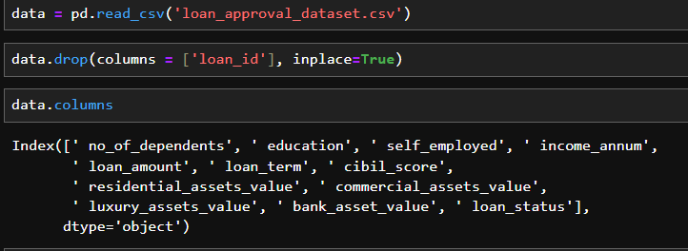

*Fig 1: Loading the Dataset*

*Fig 2: Information about the dataset*

*Fig 3: Merging the columns*

*Fig 4: Changing standardizing text responses into binary numerical format.*

*Fig 5: Output*

*Fig 6: Changing standardizing text responses into binary numerical format.*

*Fig 7: Output*

*Fig 8 : Shows the end-to-end process of applying logistic regression on scaled training data using scikit-learn, including data splitting, feature scaling, model training, and performance evaluation.*

*Fig 9 : showcases the prediction workflow using scikit-learn, where input data is pre-processed with a scaler, passed through a trained model for prediction, and both the model and scaler are saved using pickle.*

*Fig 10 : Illustrates a Streamlit-based loan prediction interface, allowing users to input financial details, which are processed and evaluated using a pre-trained model to determine loan approval status.*

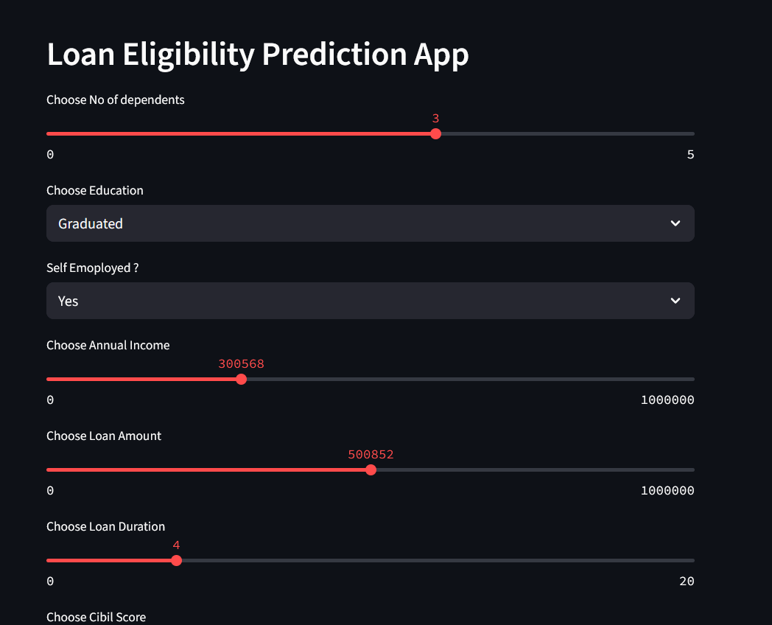

*Fig 11: Loan Eligibility Prediction App interface allowing users to input financial and personal details to assess their loan qualification.*

*Fig 12: Loan is Rejected*

*Fig 13: Loan is Approved*

**VI - FUTURE ENHANCEMENTS**

While the current Loan Eligibility Prediction system using machine learning models such as Logistic Regression and K-Nearest Neighbors provides promising results, there is significant scope for enhancement to improve accuracy, robustness, scalability, and real-world usability. These enhancements span across algorithmic improvements, data handling, model integration, and deployment strategies.

**6.1. Multi-Class Risk Prediction**

At present, the system performs binary classification to determine whether an applicant is eligible or not eligible for a loan. In the future, it can be extended to support multi-class risk profiling, categorizing applicants into:

* Low-risk (eligible)
* Medium-risk (eligible with conditions)
* High-risk (ineligible)

This classification would enable financial institutions to better assess risk and customize loan offerings based on applicant profiles.

**6.2. Integration of Advanced Machine Learning Models**

While Logistic Regression and KNN offer simplicity and interpretability, they have limitations in handling complex patterns in high-dimensional data. Future versions of the system can integrate advanced models such as:

* Random Forest
* Gradient Boosting Machines (XGBoost, LightGBM)
* Support Vector Machines  
  These models can capture non-linear relationships more effectively, leading to improved predictive performance.

**6.3. Deep Learning for Financial Forecasting**

For more sophisticated credit risk analysis, deep learning models such as Neural Networks can be explored. These models, especially when trained on large-scale financial data, can uncover intricate dependencies and patterns, enhancing accuracy in edge cases and minimizing misclassification.

**6.4. Real-Time Loan Application Scoring**

Currently, the system predicts eligibility on static data. A future goal would be to integrate the system into real-time banking applications or web portals where applicants can instantly receive eligibility decisions based on live data submissions. This would significantly streamline the loan approval process.

**6.5. Integration with Credit Bureau APIs**

The system could be enhanced by integrating data from credit bureaus (like CIBIL or Experian) to automatically fetch and include verified credit scores, previous defaults, and repayment history—critical indicators for loan approval decisions**.**

**6.6. Automated Feedback Loop**

The implementation of a feedback mechanism could help continuously improve the model. For instance, loan officers could validate or adjust the model’s prediction, and the corrected feedback could be stored and used for periodic retraining through active learning, allowing the model to evolve over time.

**6.7. Inclusion of External Factors**

In future updates, the model can incorporate external economic indicators such as inflation rate, employment trends, or market risks. These features, when combined with personal financial data, could improve forecasting accuracy in different market conditions.

**6.8. Mobile and Cloud Deployment**

Deploying the model as a mobile-friendly web app or hosting it on a cloud-based platform would allow wider access and scalability. Banks and NBFCs can integrate it into their customer-facing systems to reduce processing time and manual efforts.

**VII - CONCLUSION**

The Loan Eligibility Prediction system presented in this project demonstrates the power and effectiveness of applying machine learning algorithms in financial decision-making. By using models like Logistic Regression and K-Nearest Neighbors, the system is capable of classifying loan applicants based on their eligibility, using features such as income, employment status, credit history, and loan amount.

The entire project workflow included data collection, preprocessing, feature engineering, model training, evaluation, and testing. Both models were tested on a curated dataset and evaluated using standard metrics like accuracy, precision, recall, and confusion matrix. Logistic Regression slightly outperformed KNN in terms of overall consistency and interpretability, making it suitable for practical deployment in banking environments.

This project showcases that even traditional ML algorithms, when paired with quality preprocessing and carefully selected features, can produce reliable and actionable results in the finance domain. The predictive system not only reduces the workload of financial institutions but also accelerates the loan approval process, improving the overall customer experience.

As the financial landscape continues to evolve, so too can this project. Future enhancements such as multi-class classification, integration of advanced models, and real-time scoring can significantly expand the application’s capabilities. Moreover, by including credit bureau data, deploying the system on mobile platforms, and integrating automated feedback loops, the system can be transformed into a robust, scalable decision-support tool for financial institutions.

In conclusion, this Loan Eligibility Prediction project serves as a valuable contribution to the intersection of data science and finance, offering a foundation for intelligent, data-driven lending decisions that are both efficient and fair.

**REFERENCES**

**Bhagat, A., & Patil, S. (2021**). *Loan eligibility prediction using machine learning algorithms*. International Journal of Scientific Research in Computer Science, Engineering and Information Technology, 7(2), 45–50.

**Bansal, S., & Arora, A. (2020).** *Comparative analysis of machine learning algorithms for predicting loan eligibility*. International Journal of Computer Applications, 176(36), 1–6.

**Kaur, R., & Rani, K. (2019).** *Loan prediction using decision tree algorithm*. International Journal of Engineering and Advanced Technology (IJEAT), 8(6), 2278–3075.

**Siddiqui, T. (2022**). *Predicting loan default using machine learning techniques: Logistic regression vs KNN*. International Journal of Computer Sciences and Engineering, 10(1), 74–80.

**Dastile, X. N., Celik, T., & Potsane, M. (2020**). *Statistical and machine learning models for credit scoring: A review*. Heliyon, 6(2), e03427**.**

**Rashmi, S., & Jayanthi, D. (2021).** *Loan approval prediction using supervised machine learning techniques*. Journal of Emerging Technologies and Innovative Research, 8(4), 303–308.

**Arora, M. (2021).** *Loan approval prediction using Python*. Towards Data Science. Retrieved from <https://towardsdatascience.com>

**Subramanian, M., & Nair, A. (2020).** *A comprehensive review on credit scoring and loan approval systems using ML techniques*. International Journal of Advanced Trends in Computer Science and Engineering, 9(2), 1234–1240.

**Kaggle. (2021).** *Loan prediction dataset*. Retrieved from <https://www.kaggle.com/altruistdelhite04/loan-prediction-problem-dataset>

**Pandey, A. & Mishra, M. (2018).** *Data mining techniques for loan risk prediction*. International Journal of Engineering Research & Technology (IJERT), 7(4), 54–58.

**Géron, A. (2019).** *Hands-On Machine Learning with Scikit-Learn, Keras, and TensorFlow*. 2nd ed. O’Reilly Media.

**James, G., Witten, D., Hastie, T., & Tibshirani, R. (2013).** *An Introduction to Statistical Learning: With Applications in R*. Springer.

**Jain, M., & Raj, A. (2020).** *Loan eligibility prediction using logistic regression*. Proceedings of the International Conference on Intelligent Computing and Control Systems (ICICCS), 1181–1186.

**Jaiswal, A., & Upadhyay, A. (2022).** *Loan default prediction using machine learning algorithms*. International Journal of Research in Computer Applications and Robotics, 10(2), 1–8.

**Python Software Foundation. (2023).** *Python 3 Documentation*. Retrieved from <https://docs.python.org>

**Scikit-learn Developers. (2023).** *Scikit-learn documentation*. Retrieved from <https://scikit-learn.org>

**IBM Cloud Education. (2021).** *What is logistic regression?* Retrieved from https://www.ibm.com/cloud/learn/logistic-regression

**Brownlee, J. (2016).** *Machine Learning Mastery with Python*. Machine Learning Mastery.

**OpenAI. (2024).** *Understanding machine learning in practical scenarios*. Retrieved from <https://openai.com/research>

**UCI Machine Learning Repository. (2023**). *Lending Club dataset*. Retrieved from <https://archive.ics.uci.edu/ml/datasets/Lending+Club+Loan+Data>